Homework3

Xunzhi Li

Gradient Calculation :

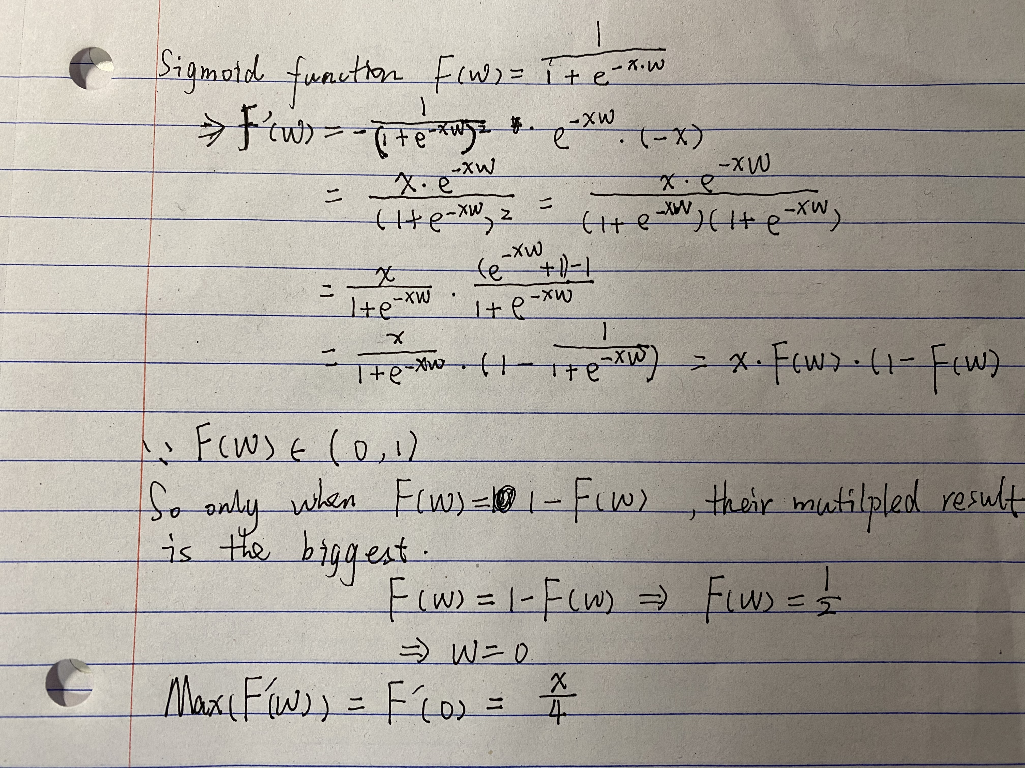

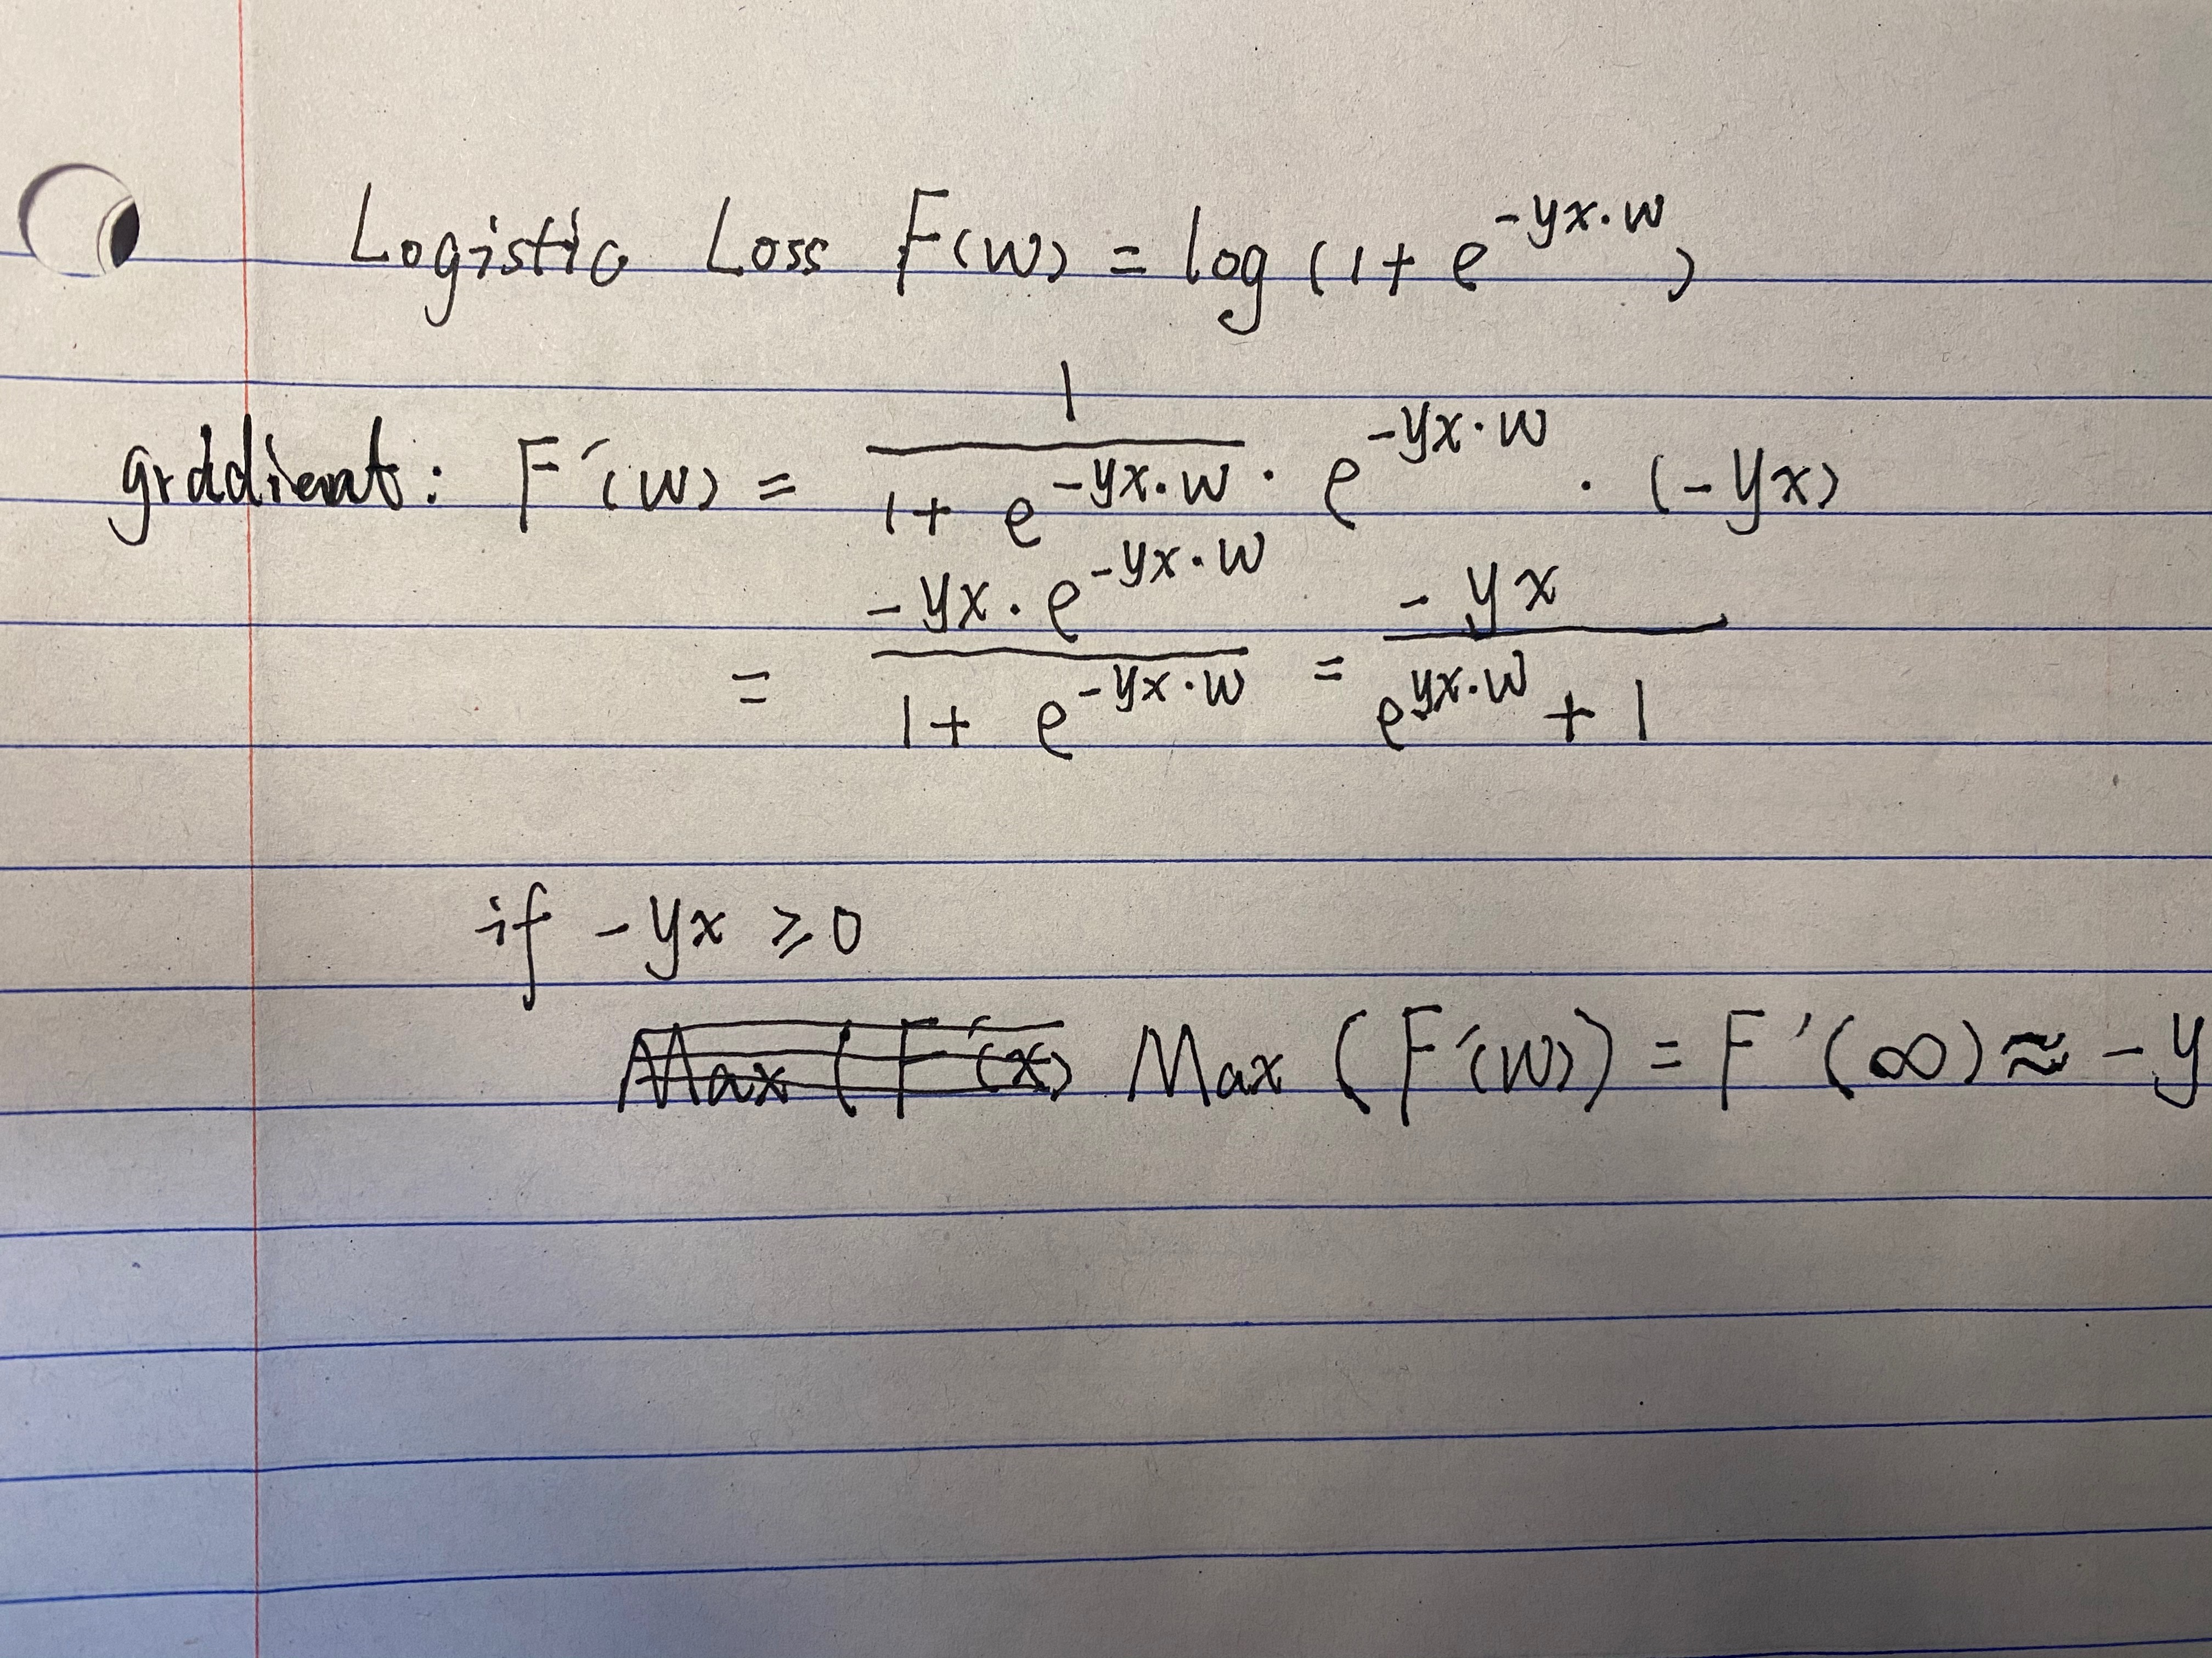

Linear Regression :

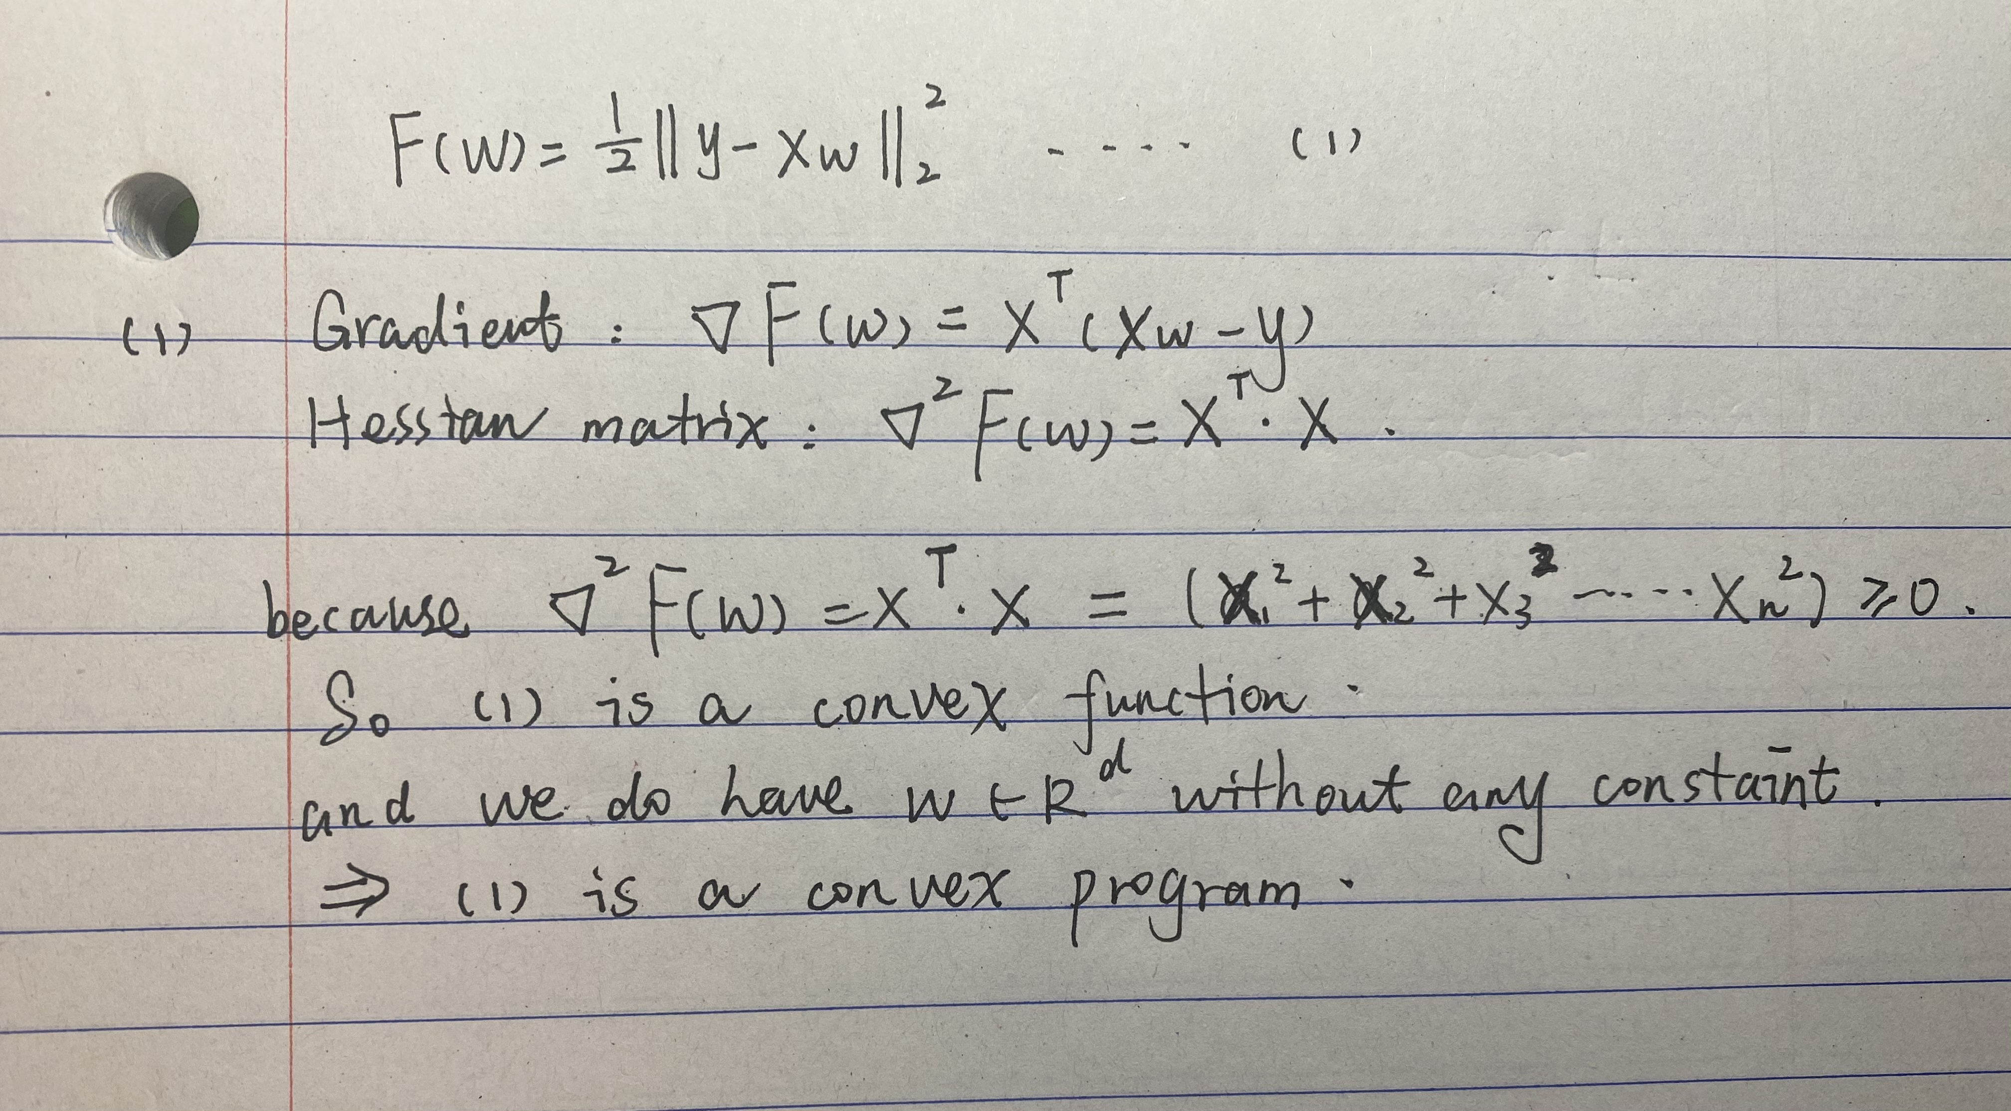

(2)Because least-squares formulation is a much more stable and reliable :

If we change 2 into 100 then

If w = 1/8, then its gradient is very small, almost equals to 0.It would lead to no progress in GD.

(3) if XTX can be 0 , F(w) is not strongly-convex.

If not , F(w) is strongly-convex.

(4)

The first graph is for 0.01lr, 01lr, lr.

The second one is for 2lr, 20lr, 100lr.

And the other three line charts are for 2lr, 20lr, 100lr individually.

My **conclusion** is the optimal learning rate for this problem is : lr = 2/(max_eigenvalue+min_eigenvalue).

When Lr < optimal one(lr0), The closer value of lr we set compared to lr0, the better GD performance it works.

When Lr > optimal one(lr0), with the value of lr increasing, it even can’t perform a GD effect.

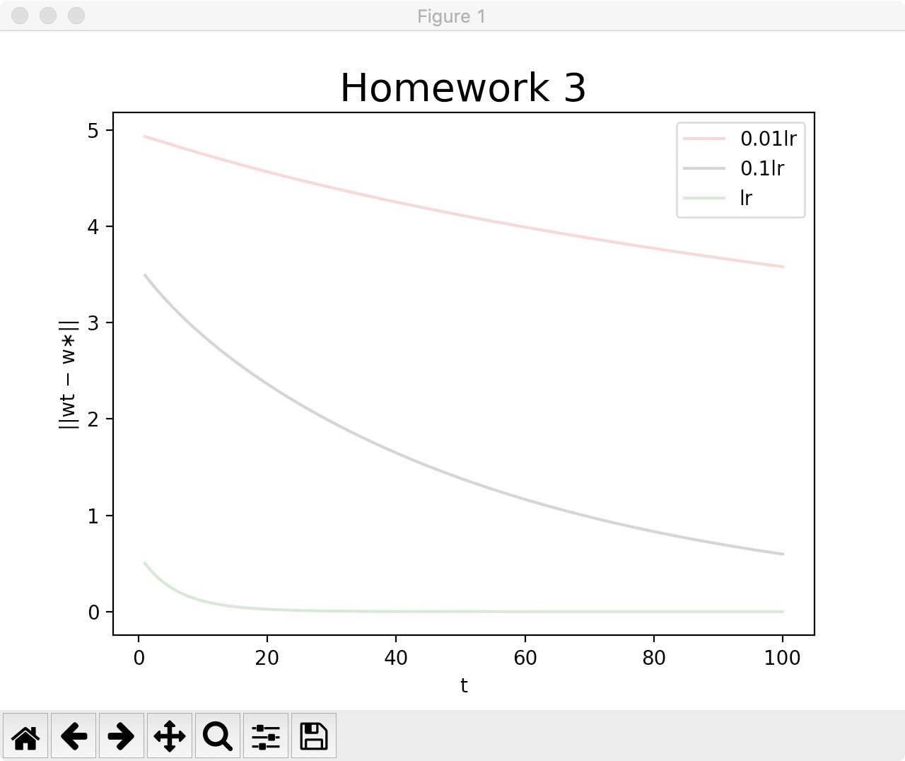

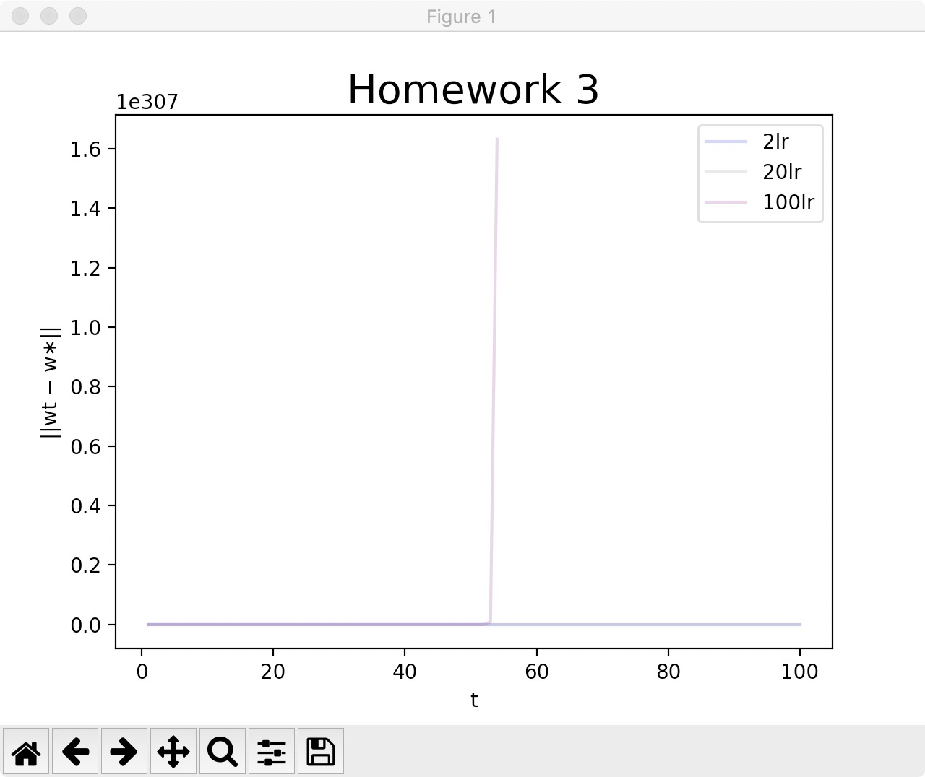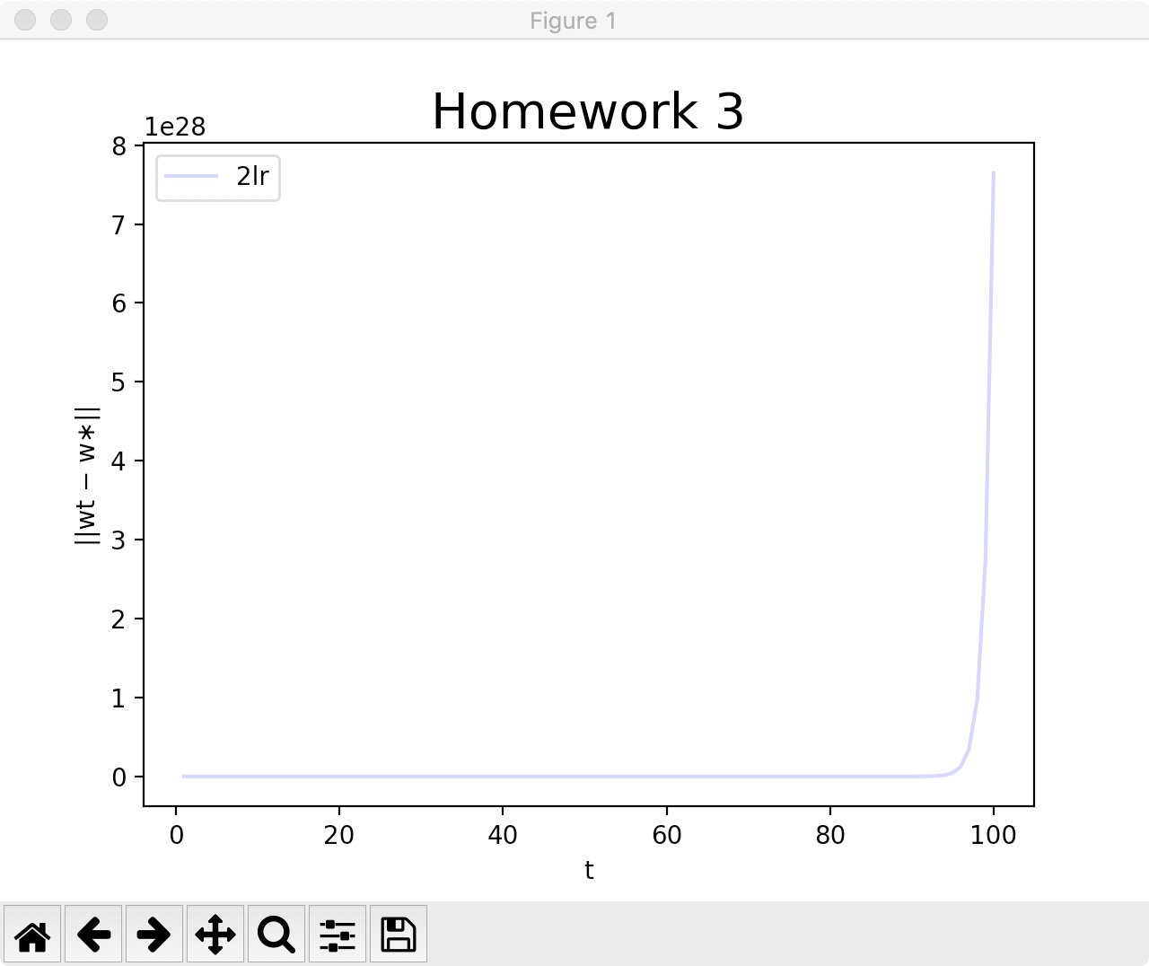

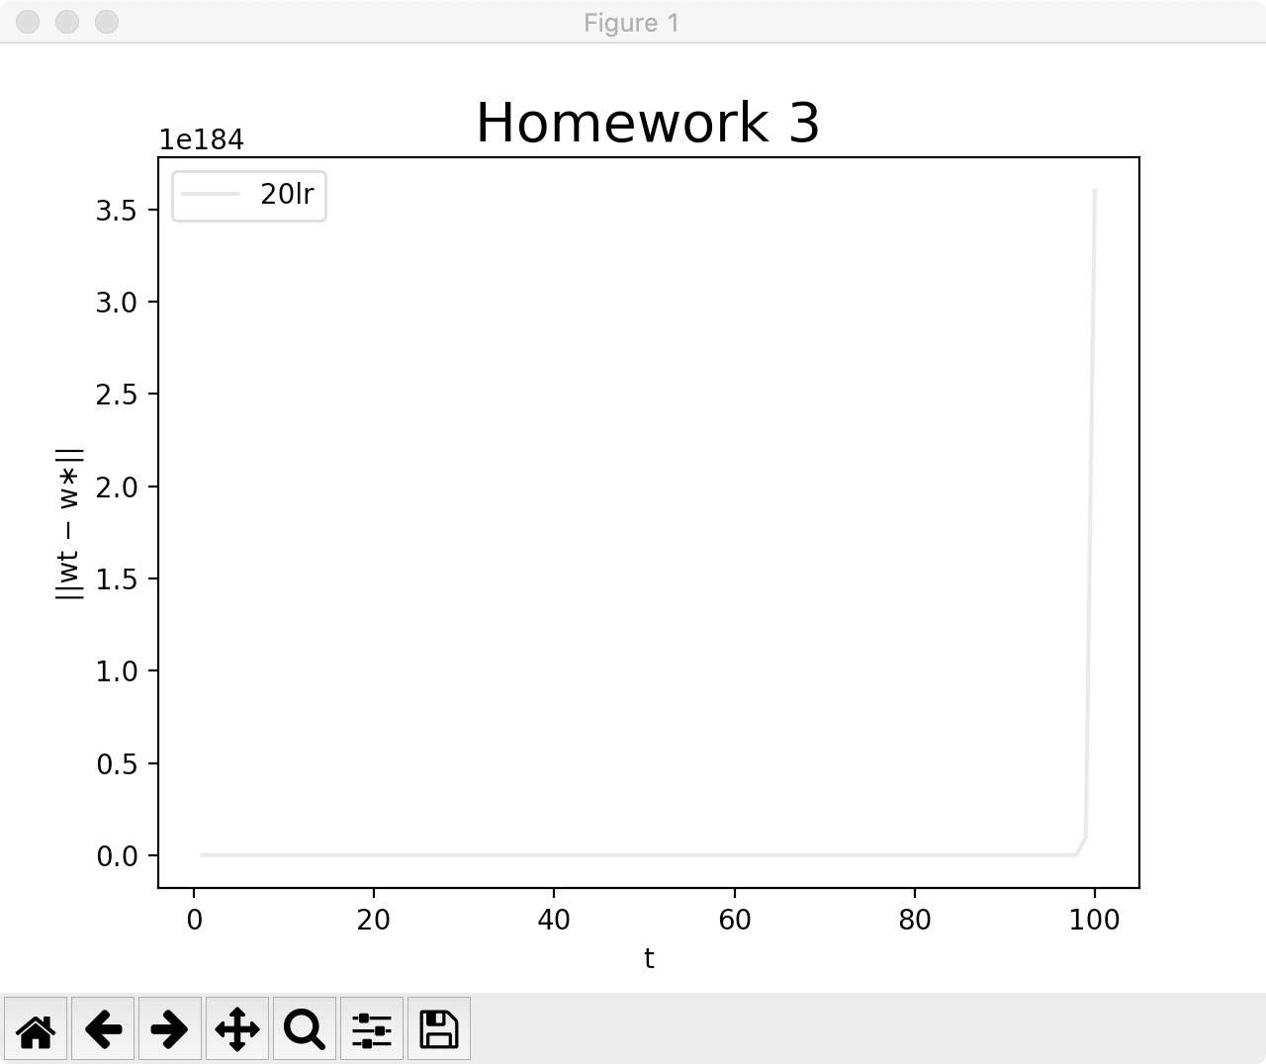 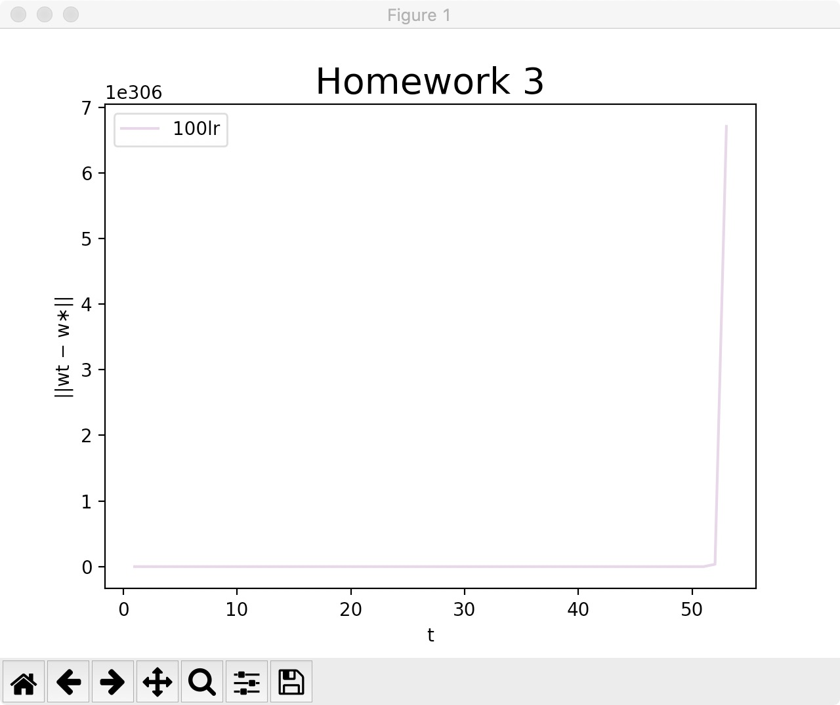

(5)

After setting d= 200, from the second chart, for lr = lr0, F(x) decrease to 0 very quickly, which means this Linear model performs very well with W(opt).

However according to the first chart, we can see that GD can’t decrease w into w* which should have equaled to W(opt) => there is something wrong with the value of w*, which is calculated by ( X⊤X−1 X⊤y ).So I think problem goes to calculation of X-1 .

